Year  7 |  | Metric Units | Non Calculator  Section
Skills and Knowledge Assessed:  - Connect decimal representations to the metric system (ACMMG135)  - Convert between common metric units of length, mass and capacity (ACMMG136)  - Solve problems involving the comparison of lengths and areas using appropriate units (ACMMG137)  - Connect volume and capacity and their units of measurement (ACMMG138)  - Solve problems involving duration, including using 12-and 24-hour time within a single time zone (ACMMG199)  - Interpret and use timetables (ACMMG139) |  |  | Name___________________
Answer all questions in the spaces provided on this test paper by:
Writing the answer in the box provided.
or
Shading in the bubble for the correct answer from the four choices provided.
Show any working out on the test paper. Calculators are not allowed.
Which measurement is the same as 8 000 metres?

8 mm 8cm 8 km 80 km
Use a ruler to measure the width of this page to the nearest cm.

cm

Which unit would be most appropriate to measure your mass (weight).

milligrams grams kilograms tonnes


Which is a reasonable estimate for the amount of soft drink in this normal sized can?

37 ml 370 ml

1 370 ml 3 700 ml

How many minutes are in 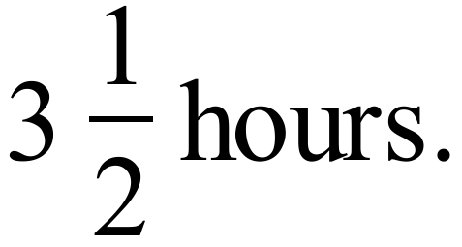

minutes.

Write the time of 5:45 pm in 24 hour time.

:

How many square mm are there in a square cm?

10

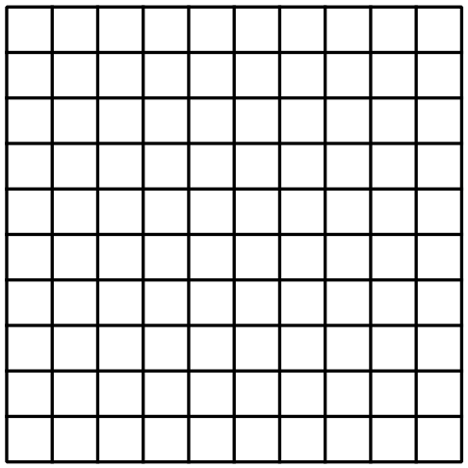 100

1 000

10 000

Which two units would be appropriate to measure the height of this desk?
centimetres or millimetres

kilometres or centimetres

kilometres or metres

kilometres or millimetres

In 2010 Anna measured her height as being 128 cm.
By 2014 she had grown to a height of 1.65 metres.
What was the increase in her height (in cm)?

cm.

When travelling to school, James walks 800 metres, then travels 6.5 km on a tram and finally walks another 300 metres to get to school.
How far does he travel altogether when going to school?

km.

Katie pours herself a drink of water from a jug which holds 2.4 litres.
She glass she uses holds 300 ml.
How many times could she fill the glass from the jug?

4 times 6 times 8 times 10 times

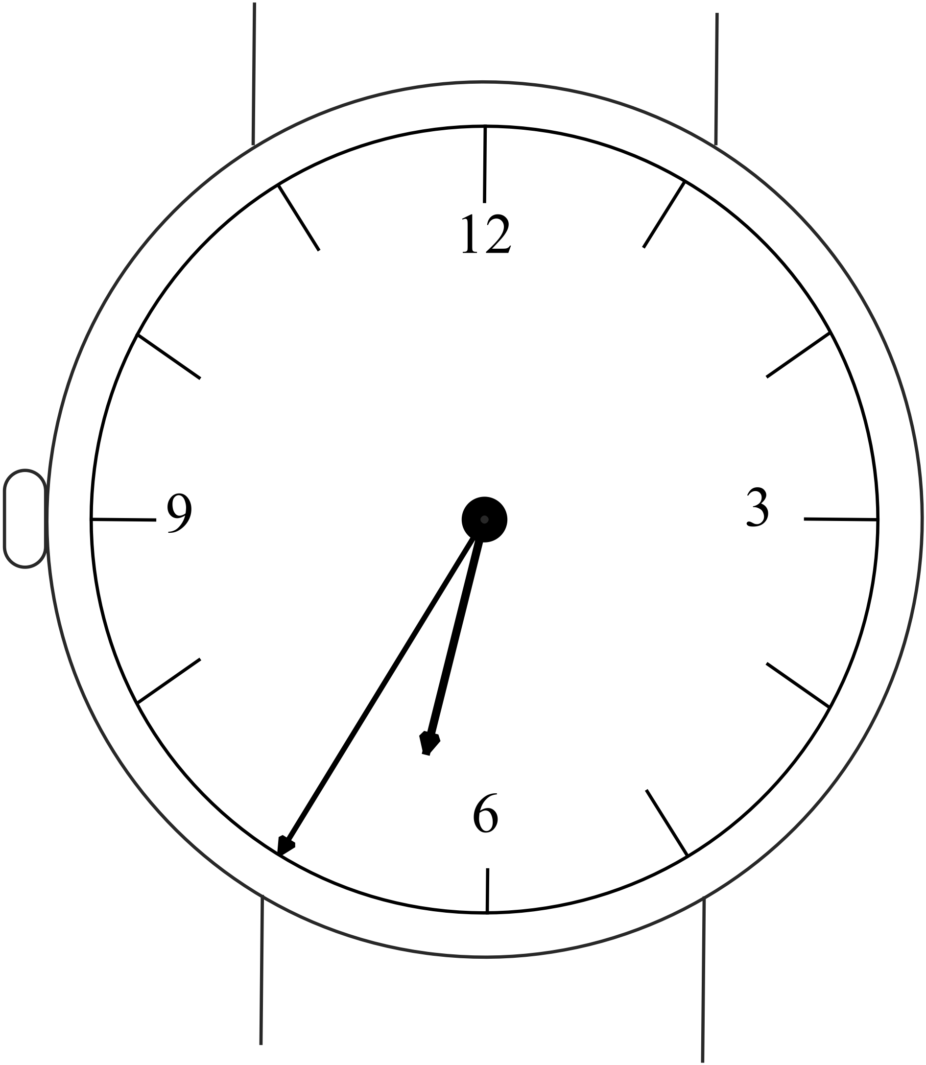Gavin woke one morning at the time shown on his watch.

He left for school at 8:25am.

How long was he awake before leaving for school?

1 hour and 20 minutes.

1 hour and 30 minutes.

1 hour and 40 minutes.

1 hour and 50 minutes.

Questions 13 – 15 refer to the tram timetable shown below.

Stop  Time | pm | pm | pm | pm | pm | pm | pm
Central Pier (Docklands) | 7:03 | 7:56 | 8:35 | 9:17 | 10:18 | 11:18 | 11:58
Bourke St | 7:05 | 7:58 | 8:37 | 9:19 | 10:20 | 11:20 | 12:00
Docklands Park | 7:09 | 8:01 | 8:40 | 9:22 | 10:23 | 11:23 | 12:03
Spencer St | 7:12 | 8:04 | 8:43 | 9:25 | 10:26 | 11:26 | 12:06
Melbourne Aquarium | 7:13 | 8:05 | 8:44 | 9:26 | 10:27 | 11:27 | 12:07
Market St | 7:15 | 8:07 | 8:46 | 9:28 | 10:29 | 11:29 | 12:09
Elizabeth St | 7:16 | 8:08 | 8:47 | 9:29 | 10:30 | 11:30 | 12:10
Swanston St | 7:17 | 8:09 | 8:48 | 9:30 | 10:31 | 11:31 | 12:11
Russell St | 7:19 | 8:10 | 8:49 | 9:31 | 10:32 | 11:32 | 12:12
Spring St | 7:21 | 8:12 | 8:51 | 9:33 | 10:34 | 11:34 | 12:14
Simpson St | 7:24 | 8:15 | 8:54 | 9:36 | 10:37 | 11:37 | 12:17
Punt Rd | 7:25 | 8:16 | 8:55 | 9:37 | 10:38 | 11:38 | 12:18
Yarra Bvd | 7:32 | 8:23 | 9:02 | 9:44 | 10:45 | 11:44 | 12:24
Hawthorn Railway Station | 7:35 | 8:26 | 9:05 | 9:47 | 10:48 | 11:47 | 12:27
Glenferrie Rd | 7:39 | 8:30 | 9:09 | 9:51 | 10:52 | 11:51 | 12:31
Camberwell Tram Depot | 7:43 | 8:34 | 9:13 | 9:55 | 10:56 | 11:55 | 12:35
Camberwell Junction | 7:44 | 8:35 | 9:14 | 9:56 | 10:57 | 11:56 | 12:36
Toorak Rd | 7:50 | 8:41 | 9:20 | 10:02 | 11:03 | 12:01 | 12:41
Warrigal Rd | 7:53 | 8:44 | 9:23 | 10:05 | 11:06 | 12:04 | 12:44
Somers St | 7:54 | 8:45 | 9:24 | 10:06 | 11:07 | 12:05 | 12:45
Middleborough Rd | 8:00 | 8:51 | 9:30 | 10:12 | 11:13 | 12:11 | 12:51
Blackburn Rd | 8:04 | 8:55 | 9:34 | 10:16 | 11:17 | 12:14 | 12:59
Stanley Rd | 8:09 | 9:00 | 9:39 | 10:21 | 11:22 | 12:19 | 1:02
Hanover Rd (Vermont Sth) | 8:10 | 9:01 | 9:40 | 10:22 | 11:23 | 12:20 | 1:04

One tram leaves the Russell St stop at 8:49 pm. How long does it take to get to the Warrigal Rd stop?

minutes

Which of these trams from Docklands takes the least time to complete the full journey to Vermont South?

The 7:03.

The 7:56.

The 9:17.

The 11:18.

Laura catches the 8:35 tram from Docklands and gets off at Swanson St to join friends for a meal which takes an hour.

She then takes another tram and gets off at Somers St and walks 5 minutes to her home.

What time does she arrive home?

pm/am

Helen’s date of birth is 15/08/2001. She received a birthday card on the 30th July 2014.

Which is true?

The card arrived 15 days early for her 12th birthday.

The card arrived 16 days early for her 12th birthday.

The card arrived 15 days early for her 13th birthday.

The card arrived 16 days early for her 13th birthday.


Alex runs 18 laps of an oval which has a circumference of 250 metres.

Lenny runs 4.8 kilometres on the open road.

Who runs the furthest, and by how many metres?

runs the furthest by metres.

At 19:56 Hannah checks the program guide on her TV and sees a program she wants to watch starts in 1 hour and twenty minutes time and lasts for 56 minutes.

Which is true?

The program starts at 9:16 pm and ends at 10:12 pm.

The program starts at 9:16 pm and ends at 10:22 pm.

The program starts at 9:26 pm and ends at 10:12 pm.

The program starts at 9:26 pm and ends at 10:12 pm.

Year  7 |  | Metric Units | Calculator Allowed  Short Answer  Section
 |  |  | Name___________________
Answer all questions in the spaces provided on this test paper by:
Writing the answer in the box provided.
or
Shading in the bubble for the correct answer from the four choices provided.
Show any working out on the test paper. Calculators are allowed.
Which of the following is the same mass as 2.4 kilograms?

24 g 240 g 2 400 g 24 000 g
Complete the statement below.

George buys a ruler which is 0.6 metres long.

Its length in centimetres is cm.


Which would be a reasonable estimate for the mass of a banana?

25 g 50 g

100 g 3 200g

Joanne goes on a run which takes 45 minutes. The run took

A quarter of an hour. Half an hour.

Three quarters of an hour. An hour and a half.

Mira makes enough cordial to fill a container which holds of 12 500 ml.
How many litres of juice is this?

litres.

What is the approximate length of the shaded rectangle, according to the ruler shown?

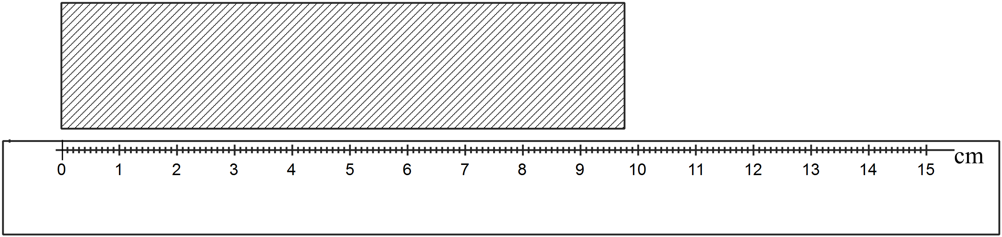
98 mm 980 mm 9 800 mm 98 000 mm

A football match starts at 3:20pm and finishes at 5:05 pm. What is the duration of the match?

hours and minutes.

Which would be a reasonable estimate for the distance from Sydney to Melbourne?

80 km 800 km 8 000 km 80 000 km

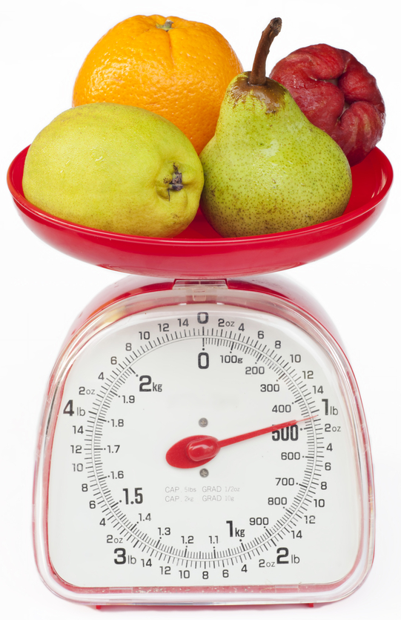
What is the mass (weight) of the fruit shown, to the nearest 50 grams?

grams

The mass of a 4WD ute is 1.6 tonnes. Emily loads a cargo which weighs 500 kg in the back of the ute. What is the combined mass of the ute and cargo (to the nearest 10th of a tonne)?

tonnes

Questions 11 – 13 refer to the train timetable below.

Perth Station | 5:23 am | 6:27 am | 6:54 am | 7:08 am
City West | 5:25 am | 6:29 am | 6:56 am | 7:10 am
West Leederville | 5:27 am | 6:31 am | 6:58 am | 7:12 am
Subiaco | 5:29 am | 6:33 am | 7:00 am | 7:14 am
Daglish | 5:30 am | 6:34 am | 7:01 am | 7:15 am
Shenton Park | 5:32 am | 6:36 am | 7:03 am | 7:17 am
Karrakatta | 5:34 am | 6:38 am | 7:05 am | 7:19 am
Loch Street | 5:35 am | 6:39 am | 7:06 am | 7:20 am
Claremont | 5:37 am | 6:41 am | 7:08 am | 7:22 am
Swanbourne | 5:39 am | 6:43 am | 7:10 am
Grant Street | 5:40 am | 6:44 am | 7:11 am
Cottesloe | 5:42 am | 6:46 am | 7:13 am
Mosman Park | 5:44 am | 6:48 am | 7:15 am
Victoria Street | 5:45 am | 6:49 am | 7:16 am
North Fremantle | 5:47 am | 6:51 am | 7:18 am
Fremantle | 5:51 am | 6:55 am | 7:22 am | 7:31 am

The 7:08 am train from Perth is an express train.

How much less time does it take to get to Freemantle compared to the other trains?

3 minutes 5 minutes 7 minutes 9 minutes

Jean catches a train from West Leederville. She needs to reach Mosman Park station by 7:10 am; in order to make a 7:15 am appointment nearby.

What is the latest time she could catch a train from West Leederville?

am

Rory checks the clock as he leaves work.

When he gets home he checks his watch.

If both show the correct time, long did it take him to get from work to home?
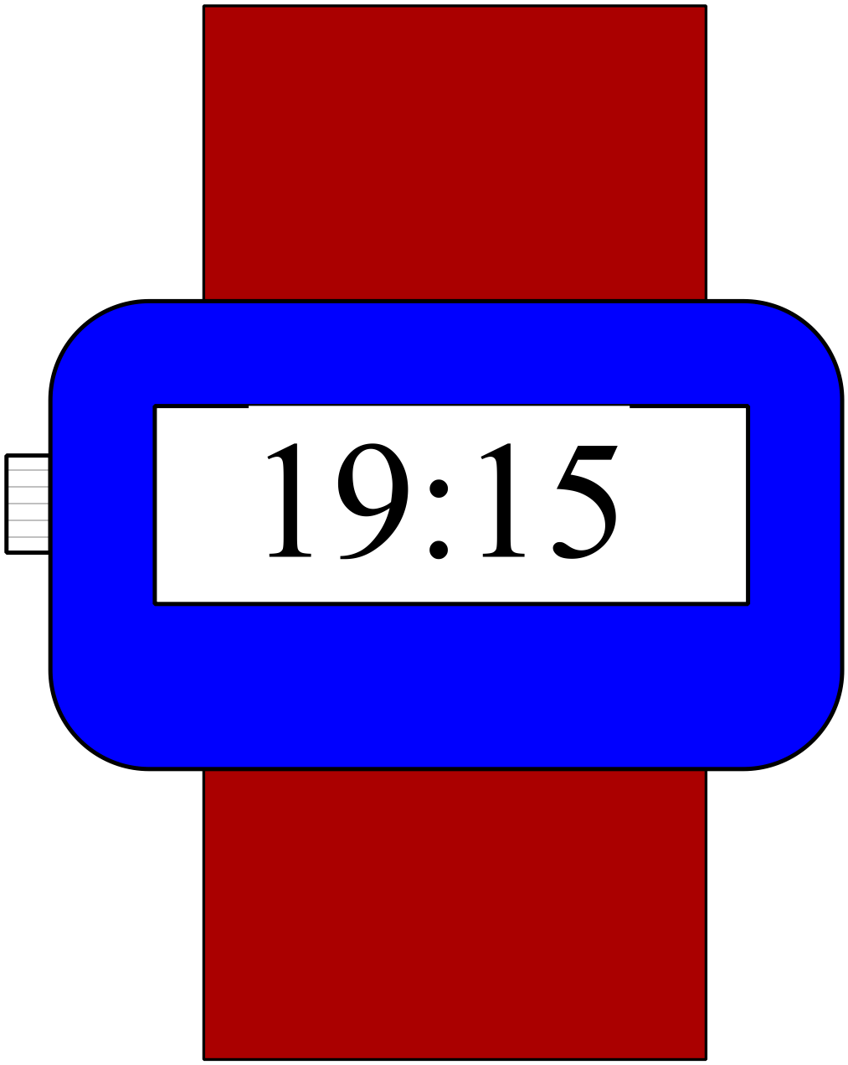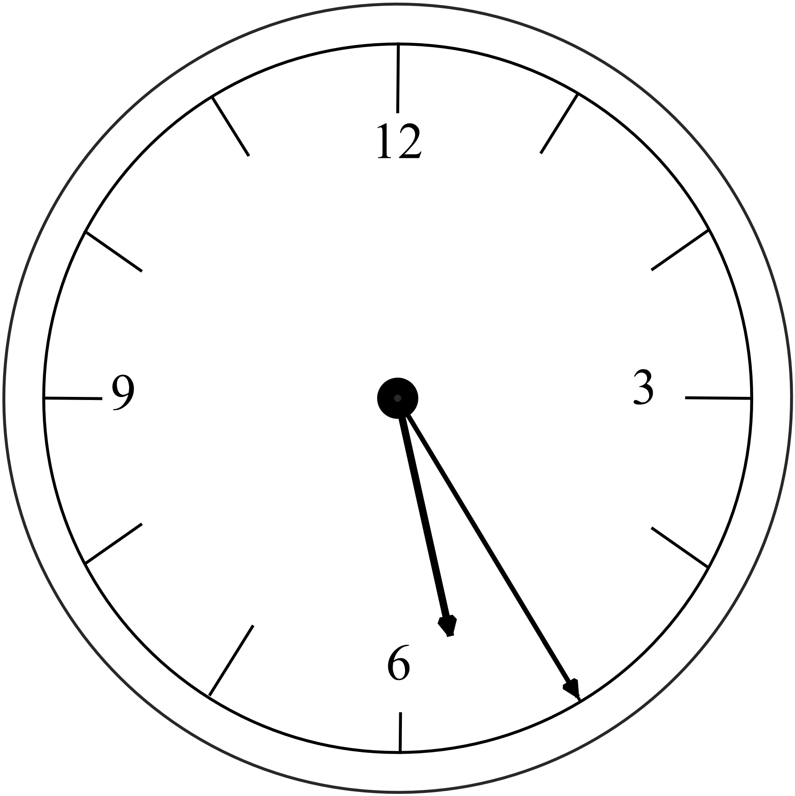

Clock at work. Rory’s watch when he gets home.

1 hour 40minutes 1 hour 50 minutes

2 hours 10 minutes 2 hours 50 minutes
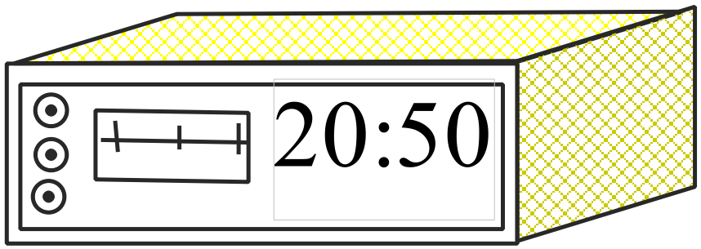Jasmine was setting her alarm at the time shown.

She sets the alarm for 6:20 the next morning.

If she goes to sleep an hour after setting the alarm, how many hours sleep does she get before the alarm sounds?

7 hours and 30 minutes.

8 hours and 10 minutes.

8 hours and 30 minutes.

9 hours and 10 minutes.

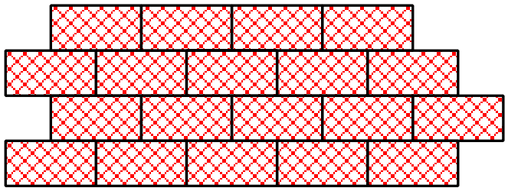A brick wall is made of bricks whose front face has an area of 360 cm².

The area of the wall is 4.5 m².

How many bricks would be needed for the wall?

12.5 75 80 125

A water storage dam has a capacity of 120 megalitres.

On average 240 kilolitres is used each day.

If there is no water added to the dam, how long will the water stored in the dam last?

days


Keira is a woodworker and she is making wooden toys for a market stall.

She bought 12 planks which are 2.4 metres long to make the toys.

Each toy requires a length of 45 cm to be cut from a plank, any shorter lengths are discarded.

Each completed toy weighs 900 grams.

What is the total mass of the completed toys?

43.2 kg 54.0 kg 57.6 kg 60.0 kg

Shaun worked five shifts last week.

The times for his shifts were :

8:20 (eight hours and twenty minutes)
8:55 (eight hours and fifty five minutes)
9:45 (nine hours and forty five minutes)
8:45 (eight hours and forty five minutes)
8:45 (eight hours and forty five minutes)

He is paid at overtime rates if he works more than 35 hours in a week.

How many hours and minutes of overtime did he work last week?

hours and minutes.

Metric Units
ANSWERS
Non Calculator Section ( 1 mark each)

Which measurement is the same as 8 000 metres?

8 mm 8cm 8 km 80 km
Use a ruler to measure the width of this page to the nearest cm.
Depends at what size page is printed.

cm

Which unit would be most appropriate to measure your mass (weight).

milligrams grams kilograms tonnes

Which is a reasonable estimate for the amount of soft drink in this normal sized can?

37 ml 370 ml

1 370 ml 3 700 ml

How many minutes are in
210
minutes.

Write the time of 5:45 pm in 24 hour time.

17:45

How many square mm are there in a square cm?

10
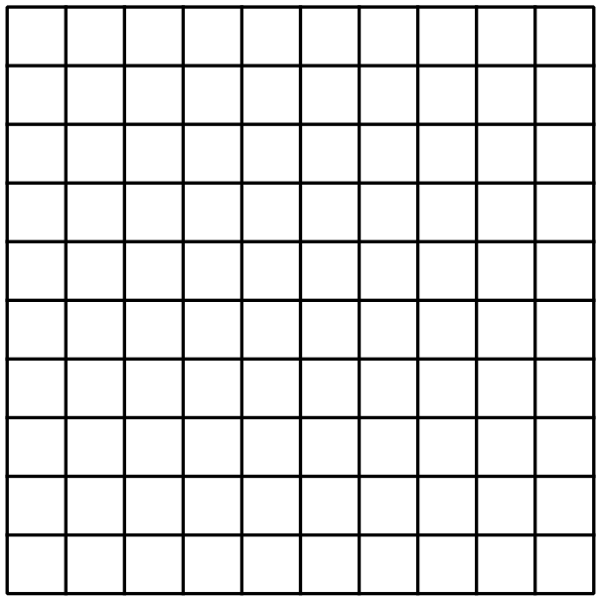 100

1 000

10 000

Which two units would be appropriate to measure the height of this desk?
centimetres or millimetres

kilometres or centimetres

kilometres or metres

kilometres or millimetres

In 2010 Anna measured her height as being 128 cm.
By 2014 she had grown to a height of 1.65 metres.
What was the increase in her height (in cm)?

37 cm.

When travelling to school, James walks 800 metres, then travels 6.5 km on a tram and finally walks another 300 metres to get to school.
How far does he travel altogether when going to school?
7.6
 km.

Katie pours herself a drink of water from a jug which holds 2.4 litres.
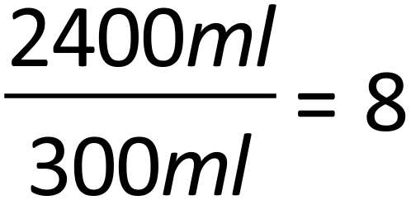
She glass she uses holds 300 ml.
How many times could she fill the glass from the jug?

4 times 6 times 8 times 10 times

Gavin woke one morning at the time shown on his watch.
He left for school at 8:25am.

For how long was he awake before leaving for school?

1 hour and 20 minutes.

1 hour and 30 minutes.

1 hour and 40 minutes.

1 hour and 50 minutes.

Questions 13 – 15 refer to the tram timetable shown below.

Stop  Time | pm | pm | pm | pm | pm | pm | pm
Central Pier (Docklands) | 7:03 | 7:56 | 8:35 | 9:17 | 10:18 | 11:18 | 11:58
Bourke St | 7:05 | 7:58 | 8:37 | 9:19 | 10:20 | 11:20 | 12:00
Docklands Park | 7:09 | 8:01 | 8:40 | 9:22 | 10:23 | 11:23 | 12:03
Spencer St | 7:12 | 8:04 | 8:43 | 9:25 | 10:26 | 11:26 | 12:06
Melbourne Aquarium | 7:13 | 8:05 | 8:44 | 9:26 | 10:27 | 11:27 | 12:07
Market St | 7:15 | 8:07 | 8:46 | 9:28 | 10:29 | 11:29 | 12:09
Elizabeth St | 7:16 | 8:08 | 8:47 | 9:29 | 10:30 | 11:30 | 12:10
Swanston St | 7:17 | 8:09 | 8:48 | 9:30 | 10:31 | 11:31 | 12:11
Russell St | 7:19 | 8:10 | 8:49 | 9:31 | 10:32 | 11:32 | 12:12
Spring St | 7:21 | 8:12 | 8:51 | 9:33 | 10:34 | 11:34 | 12:14
Simpson St | 7:24 | 8:15 | 8:54 | 9:36 | 10:37 | 11:37 | 12:17
Punt Rd | 7:25 | 8:16 | 8:55 | 9:37 | 10:38 | 11:38 | 12:18
Yarra Bvd | 7:32 | 8:23 | 9:02 | 9:44 | 10:45 | 11:44 | 12:24
Hawthorn Railway Station | 7:35 | 8:26 | 9:05 | 9:47 | 10:48 | 11:47 | 12:27
Glenferrie Rd | 7:39 | 8:30 | 9:09 | 9:51 | 10:52 | 11:51 | 12:31
Camberwell Tram Depot | 7:43 | 8:34 | 9:13 | 9:55 | 10:56 | 11:55 | 12:35
Camberwell Junction | 7:44 | 8:35 | 9:14 | 9:56 | 10:57 | 11:56 | 12:36
Toorak Rd | 7:50 | 8:41 | 9:20 | 10:02 | 11:03 | 12:01 | 12:41
Warrigal Rd | 7:53 | 8:44 | 9:23 | 10:05 | 11:06 | 12:04 | 12:44
Somers St | 7:54 | 8:45 | 9:24 | 10:06 | 11:07 | 12:05 | 12:45
Middleborough Rd | 8:00 | 8:51 | 9:30 | 10:12 | 11:13 | 12:11 | 12:51
Blackburn Rd | 8:04 | 8:55 | 9:34 | 10:16 | 11:17 | 12:14 | 12:59
Stanley Rd | 8:09 | 9:00 | 9:39 | 10:21 | 11:22 | 12:19 | 1:02
Hanover Rd (Vermont Sth) | 8:10 | 9:01 | 9:40 | 10:22 | 11:23 | 12:20 | 1:04

How many minutes does it take the tram which leaves the Russell St stop at 8:49 pm to get to the Warrigal Rd stop?
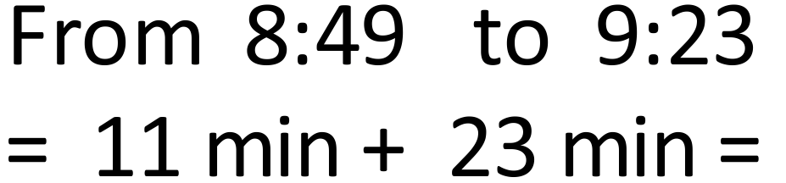
34
minutes

Which of these trams from Docklands takes the least time to complete the full journey to Vermont South?
The 7:03.
The 7:56.
The 9:17.
The 11:18.

Laura catches the 8:35 tram from Docklands and gets off at Swanson St to join friends for a meal which takes an hour.
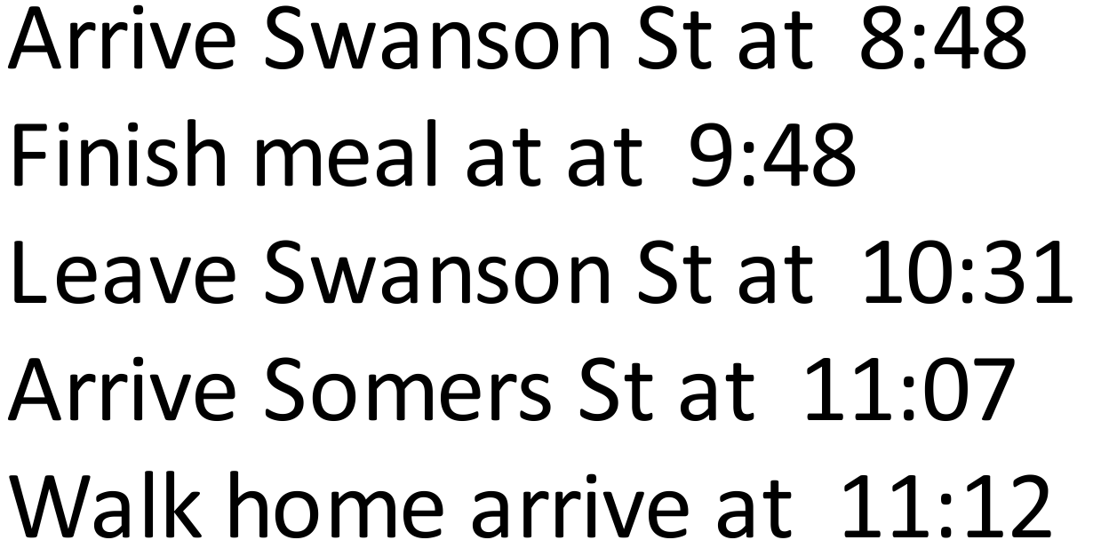

She then takes another tram and gets off at Somers St and walks 5 minutes to her home.

What time does she arrive home?
11:12
pm/am

Helen’s date of birth is 15/08/2001. She received a birthday card on the 30th July 2014.

Which is true?
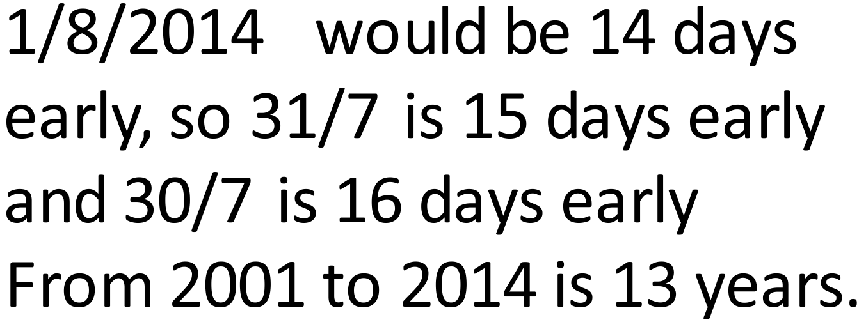

The card arrived 15 days early for her 12th birthday.

The card arrived 16 days early for her 12th birthday.

The card arrived 15 days early for her 13th birthday.

The card arrived 16 days early for her 13th birthday.

Alex runs 18 laps of an oval which has a circumference of 250 metres.

Lenny runs 4.8 kilometres on the open road.

Who runs the furthest, and by how many metres?
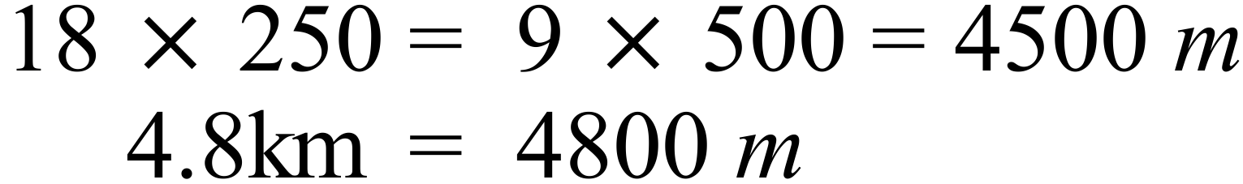
Lenny
300
runs the furthest by metres.

At 19:56 Hannah checks the program guide on her TV and sees a program she wants to watch starts in 1 hour and twenty minutes and lasts for 56 minutes.

Which is true?
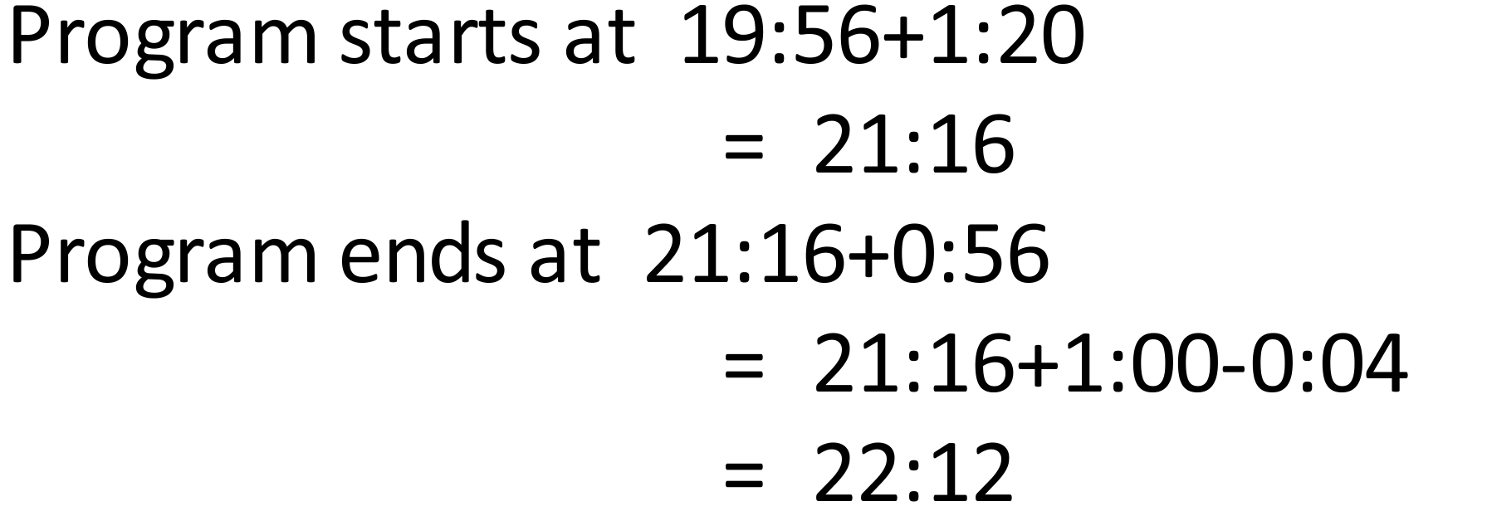

The program starts at 9:16 pm and ends at 10:12 pm.

The program starts at 9:16 pm and ends at 10:22 pm.

The program starts at 9:26 pm and ends at 10:12 pm.

The program starts at 9:26 pm and ends at 10:12 pm.

Calculator Allowed Short Answer Section ( 1 mark each)

Which of the following is the same mass as 2.4 kilograms?

24 g 240 g 2 400 g 24 000 g
Complete the statement below.

George buys a ruler which is 0.6 metres long.
60
Its length in centimetres is cm.

Which would be a reasonable estimate for the mass of a banana?

25 g 50 g

100 g 3 200g

Joanne goes on a run which takes 45 minutes. The run took:

A quarter of an hour. Half an hour.

Three quarters of an hour. An hour and a half.

Mira makes enough cordial to fill a container which holds of 12 500 ml.
How many litres of juice is this?
12.5
litres.

What is the approximate length of the shaded rectangle, according to the ruler shown?

98 mm 980 mm 9 800 mm 98 000 mm

A football match starts at 3:20pm and finishes at 5:05 pm. What is the duration of the match?

1
45
hours and minutes.

Which would be a reasonable estimate for the distance from Sydney to Melbourne?
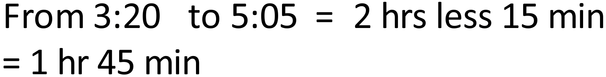

80 km 800 km 8 000 km 80 000 km

What is the mass (weight) of the fruit shown, to the nearest 50 grams?

450
grams

The mass of a 4WD ute is 1.6 tonnes. Emily loads a cargo which weighs 500 kg in the back of the ute. What is the combined mass of the ute and cargo (to the nearest 10th of a tonne)?


2.1
tonnes

Questions 11 – 13 refer to the train timetable below.

Perth Station | 5:23 am | 6:27 am | 6:54 am | 7:08 am
City West | 5:25 am | 6:29 am | 6:56 am | 7:10 am
West Leederville | 5:27 am | 6:31 am | 6:58 am | 7:12 am
Subiaco | 5:29 am | 6:33 am | 7:00 am | 7:14 am
Daglish | 5:30 am | 6:34 am | 7:01 am | 7:15 am
Shenton Park | 5:32 am | 6:36 am | 7:03 am | 7:17 am
Karrakatta | 5:34 am | 6:38 am | 7:05 am | 7:19 am
Loch Street | 5:35 am | 6:39 am | 7:06 am | 7:20 am
Claremont | 5:37 am | 6:41 am | 7:08 am | 7:22 am
Swanbourne | 5:39 am | 6:43 am | 7:10 am
Grant Street | 5:40 am | 6:44 am | 7:11 am
Cottesloe | 5:42 am | 6:46 am | 7:13 am
Mosman Park | 5:44 am | 6:48 am | 7:15 am
Victoria Street | 5:45 am | 6:49 am | 7:16 am
North Fremantle | 5:47 am | 6:51 am | 7:18 am
Fremantle | 5:51 am | 6:55 am | 7:22 am | 7:31 am
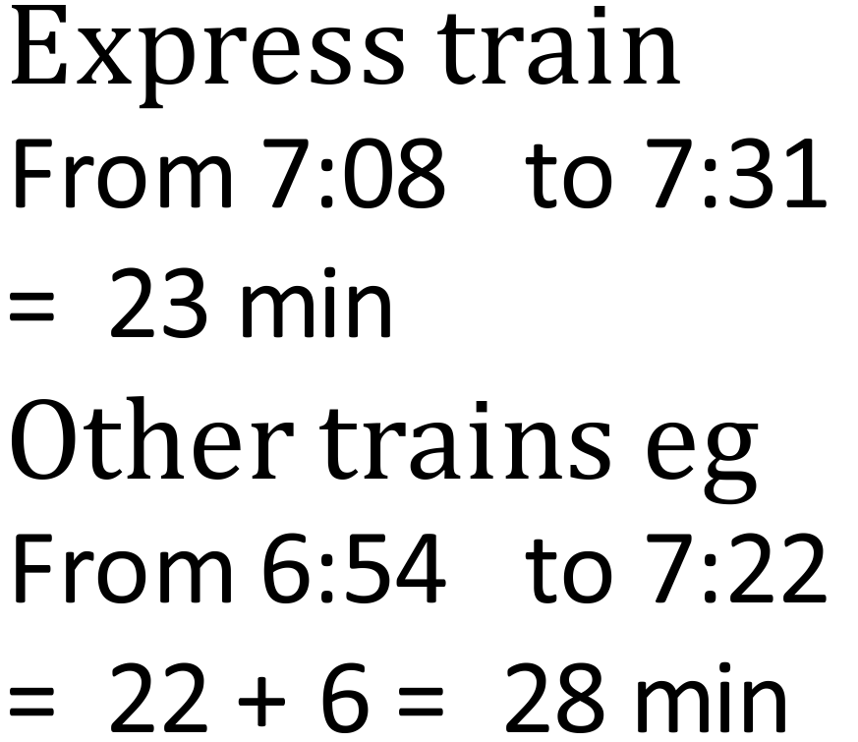
The 7:08 am train from Perth is an express train. Working see above

How much less time does it take to get to Freemantle compared to the other trains?

3 minutes 5 minutes 7 minutes 9 minutes

Jean catches a train from West Leederville. She needs to reach Mosman Park station by 7:10 am; in order to make a 7:15 am appointment nearby.

What is the latest time she could catch a train from West Leederville?
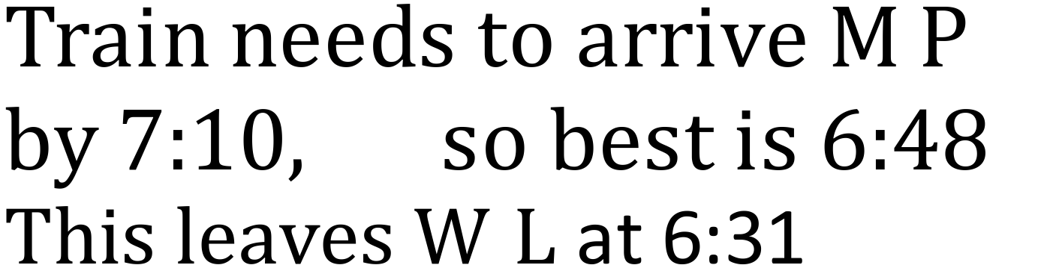
6:31
am

Rory checks the clock as he leaves work.

When he gets home he checks his watch.

If both show the correct time, long did it take him to get from work to home?

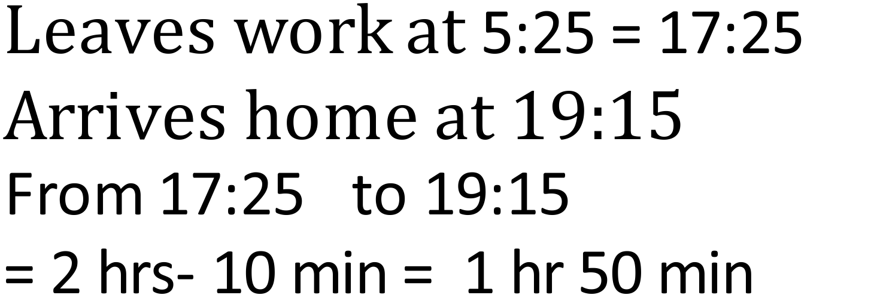

Clock at work. Rory’s watch when he gets home.

1 hour 40minutes 1 hour 50 minutes

2 hours 10 minutes 2 hours 50 minutes
Jasmine was setting her alarm at the time shown.

She sets the alarm for 6:20 the next morning.

If she goes to sleep an hour after setting the alarm, how many hours sleep does she get before the alarm sounds?
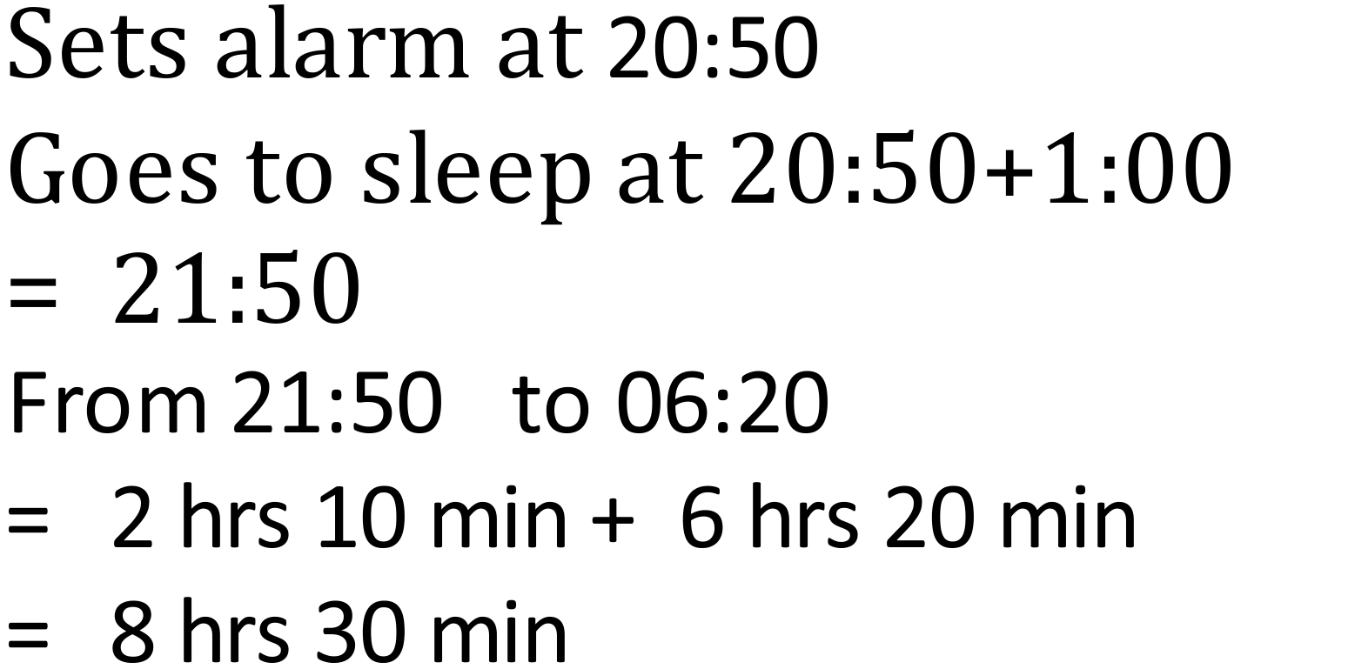

7 hours and 30 minutes.

8 hours and 10 minutes.

8 hours and 30 minutes.

9 hours and 10 minutes.

A brick wall is made of bricks whose front face has an area of 360 cm².
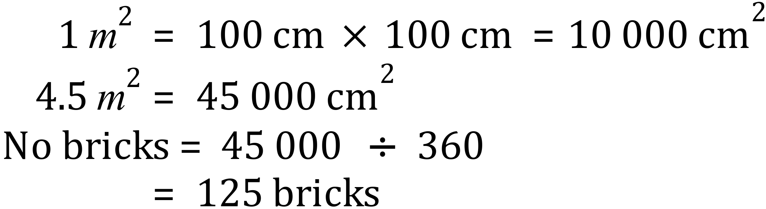

The area of the wall is 4.5 m².

How many bricks would be needed for the wall?

12.5 75 80 125

A water storage dam has a capacity of 120 megalitres.
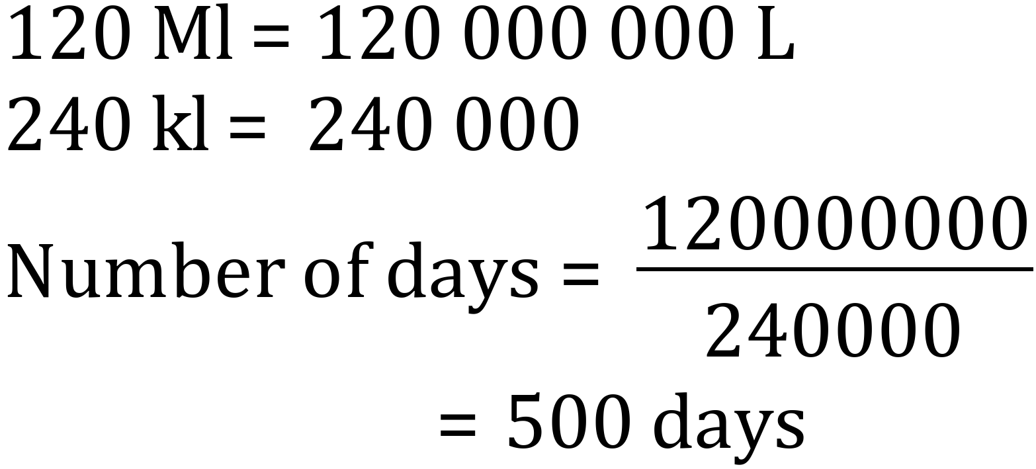

On average 240 kilolitres is used each day.

If there is no water added to the dam, how long will the water stored in the dam last?
500
days

Keira is a woodworker and she is making wooden toys for a market stall.
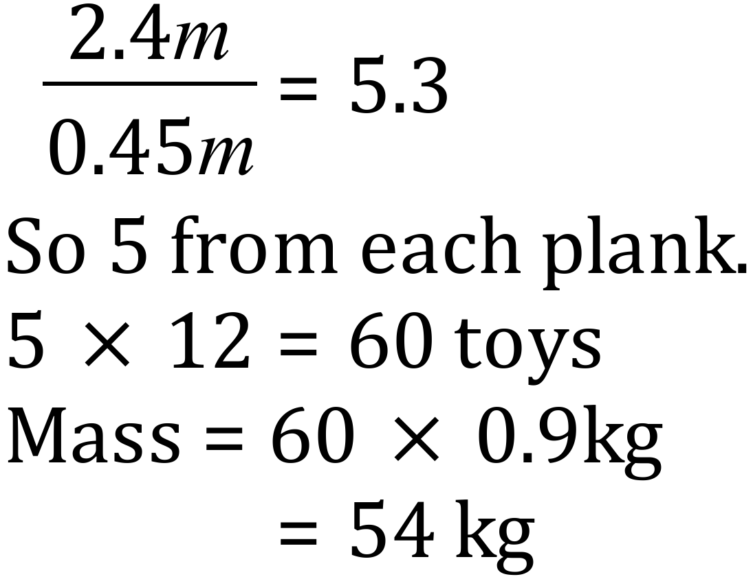

She bought 12 planks which are 2.4 metres long to make the toys.

Each toy requires a length of 45 cm to be cut from a plank, any shorter lengths are discarded.

Each completed toy weighs 900 grams.

What is the total mass of the completed toys?

43.2 kg 54.0 kg 57.6 kg 60.0 kg

Shaun worked five shifts last week.
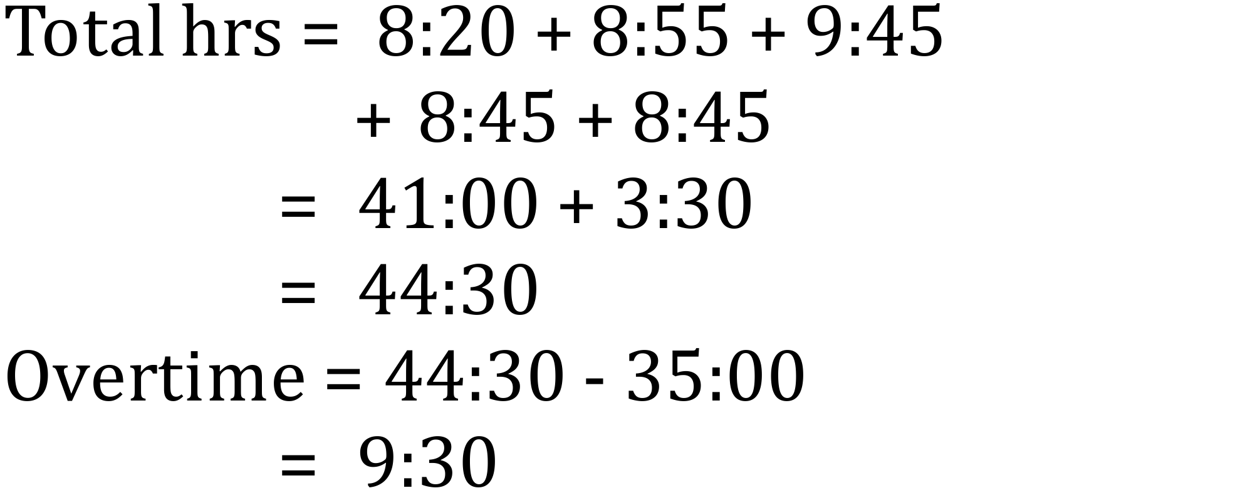

The times for his shifts were :

8:20 (eight hours and twenty minutes)
8:55 (eight hours and fifty five minutes)
9:45 (nine hours and forty five minutes)
8:45 (eight hours and forty five minutes)
8:45 (eight hours and forty five minutes)

He is paid at overtime rates if he works more than 35 hours in a week.

How many hours and minutes of overtime did he work last week?
9
30
hours and minutes.

